**Project Report:**

**Diet Mobile Application - Munch Healthy**

Dhruv Rana

CSIT335_01SP24 – Human Computer Interaction

May 07, 2024

Dr. Hongbo Zhou

**Sections Table of Contents Pages**

**1. Proposal 2**

**2. User Interviews and Requirements Analysis 3**

A.1: List of User Interviews 3

A.2: List of Initial Tasks 5

B.1: List of User Discussions on Tasks 6

B.2: Lists of Revised Tasks 7

B.3: Revised List of Users 9

C. Literature Synopsis 9

**3. Low Fidelity Prototypes 11**

Step 1 Design 11

Prototype 1 11

Prototype 2 13

Step 2 Evaluation 16

Step 3 Choice and Refinement 17

Step 4 Finalized Design 18

Storyboard 18

User Experience Map 20

Step 5 Lesson Learned 22

**4. Digital Prototype 23**

Sign In Page 23

Sign Up Page 23

Survey Page 1 24

Survey Page 2 24

Calorie Counter Page 1 25

Breakfast Recent Food Items Page 25

Breakfast Favorite Food Items Page 26

Keto Hashbrown Egg Cups Details Page 26

Calorie Counter Page 2 27

Daily Task Page 28

Meals Page 28

Diet Plan Page 29

Profile Page 30

**5. Implementation and Future Plans 31**

**6. Citations 33**

# **1. Proposal**

Munch Healthy is a diet mobile application. Living healthy has become a great strive for people, whether young or old. A key method to staying healthy besides just exercising is eating healthy. It is important to eat foods that are appropriate for your body and your health goals. Eating the right amount of calories, staying hydrated, and proper nutrition, all these factors help contribute to a healthy lifestyle and a healthy body. However, many people are misinformed or are just unaware of what foods to eat, how much to eat, and just what is right for them. This is where the diet app Munch Healthy comes into play to help people make healthier dietary choices, keep track of their health goals, and keep track of their calorie intake.

The target users for the diet mobile application Munch Healthy are teenagers, and young adults, between the ages of 18 and 30, who are conscious about their health, and eating habits, and wish to eat healthy, but don’t know how. These users can adapt to and use new technologies and are on their phones all day long. These users are busy in their school and work environment and put little care into their diet. These users are also more active in appearances, body, and health so a diet app is just the help they need. This app intends to help teens and young adults take care of their bodies from a dietary approach. Other possible users are athletes, nutritionists, doctors, patients, and software engineers who might interact with the application. It does not matter if the user is physically active, as the app will give the user dietary information based on their personal needs. This app will help complement their daily life and eating habits, easing them into a healthier lifestyle.

As a diet mobile application, the app will provide dietary information and recommendations to the user based on their requirements. Some of the features of the application include a dietary survey to help prepare a diet meal plan for the user. The user will be able to select the recommended diet meal plan from the survey or choose their plan, based on their personal needs or preferences. Each user will have a User Profile composed of their personal information like name and email. This app will be able to be paired with a smart watch for an easy and quick way to keep track of your calorie intake. The app will keep track of the amount of calories consumed by the user throughout the day. If the user is on a dietary plan, the app will modify recommendations for food items. The app will also remind the user to eat the recommended food at the designated times by giving them a notification on their phone or smartwatch and then adding the calories of the food to the calorie counter. If the user deviates from the plan, it will give the user the ability to adjust the calories by adding the calories they have consumed, in addition to identifying the food they ate as junk food, meat dishes, dairy, vegetables, and more. The application will have the function to view and share meal plans, and foods with others on social media.

# **2. User Interviews and Requirements Analysis**

## A.1: List of User Interviews

**User 001:**

* Age: 24
* Gender: Male
* Occupation: Track and Field
* General description: A college student that does track and field looking for ways to eat better, and keeps track of what he eats.
* What’s the hardest thing about following a diet?

“The hardest part about a diet is being consistent all the time, and just following it. People tend to fall off very quickly if they are not motivated enough.”

* What motivates you to eat healthy? Are there some methods or tricks you use to keep yourself from losing focus?

“What keeps me motivated is being a part of the track and field team. Having a goal of being a better and faster runner helps to keep me motivated in being conscious about what I eat. Though I do tend to take breaks and eat some not so healthy foods. You know, as a way to treat myself, after each little fitness goal.”

* What do you look for in a diet plan or a dietary guideline?

“I look for personalization in my diet. As an athlete I know that everyone’s body works differently and I know what my body needs, but sometimes I don’t. I like having a balance in my diet. Also, the steps for a diet plan should be simple and easy to understand, not too long or else I won’t bother reading them.”

* Have you used a diet application before? What were some features you liked about it?

“It wasn’t a diet app in the truest sense, but it basically helped track the foods I ate into categories, like vegetables, grains, dairy, and fruits. I just had to input how much I think I ate from each category and it would give a daily summary of my eating habit. As for what I liked, well I liked the daily summary of my eating habits, generating reports is very helpful for me.”

* What feature(s) do you look for in a diet application?

“Maybe sending notifications to me at the right time to remind me to eat, since I tend to take late lunch breaks or even just forget lunch just for my class assignments and work.”

* How do you keep track of your physical activity, especially what you eat?

“I used my smartwatch to keep track of how many calories I burned, number steps, and all that for the day. As for what I ate, well I would look at the calorie and nutrition facts on the food I buy, and avoid foods that felt or looked like they contained too many calories.”

* Are you satisfied with how you currently keep track of your diet?

“Not at all. It is more stressful than helpful.”

**User 002:**

* Age: 33
* Gender: Male
* Occupation: Office worker
* General Description: Works as a desk assistant in an accounting firm.
* What’s the hardest thing about following a diet?

“I don’t know much about dieting, but I think the hardest thing is commitment and knowing what to eat and what not to eat.”

* What motivates you to eat healthy? Are there some methods or tricks you use to keep yourself from losing focus?

“I don’t eat healthy. I don’t have the time to think about eating a healthy meal or even plan stuff like that. I just eat what I like, and what I can make. If I could eat healthy, I would.”

* What do you look for in a diet plan or a dietary guideline?

“Well since I know nothing about how to do proper dieting or even what nutritions and stuff like that to eat, I would rather be recommended what to eat based on what I need. I want to ease myself into a diet plan, instead of being forced. I like to have flexibility in my eating, and obviously want to eat tasty food.”

* Have you used a diet application before? What were some features you liked about it?

“Nope, never.”

* What feature(s) do you look for in a diet application?

“The app should be able to pair up with my FitBit so I can keep track of my progress all the time. It should also allow me to change my diet plan if I feel like it.”

* How do you keep track of your physical activity, especially what you eat?

“I used my Fitbit to keep track of my physical activity like steps and calories burned. Again I didn’t keep track of eating habits.”

* Are you satisfied with how you currently keep track of your diet?

“Well no since I didn’t really keep track of my diet. I am hoping I can get into it in a fun way, of course.”

**User 003:**

* Age: 26
* Gender: Female
* Occupation: Teacher
* General Description: Works as a teacher in an elementary school.
* What’s the hardest thing about following a diet?

“I think people see diet as bland and untasty food so most people don’t start it at all. And if they do start a diet, they give up. They are not motivated to follow a routine.”

* What motivates you to eat healthy? Are there some methods or tricks you use to keep yourself from losing focus?

“I eat healthy to stay in good health. It helps to keep my body in peak condition and I stay in shape. As for how not to lose focus, make dieting a fun and rewarding activity. When something is fun and enjoyable, everyone tends to like it, even kids.”

* What do you look for in a diet plan or a dietary guideline?

“I don’t have much preference in diet plans, as long as it shows me results, I am fine with anything.”

* Have you used a diet application before? What were some features you liked about it?

“Yes. I currently use MyPlate. I like how it uses an awarding system to keep track of my dietary progress and keeps me up to date with everything. It just makes dieting into a game. I like how I can share my progress with my friends and family, turning it into a social activity.”

* What feature(s) do you look for in a diet application?

“I think it would be helpful if the app had the ability to allow you to add foods that are not conventionally eaten into the food catalog so that it can keep track of all types of foods a person eats. You know, like personalized recipes or something like that.”

* How do you keep track of your physical activity, especially what you eat?

“Like most people these days, I use my Apple Watch with MyPlate to keep track of physical activity. You tend to move a lot, especially when working with little kids. As for what I eat, I just follow a regular schedule for my lunch and dinner, planning out some days in advance. After a while, it just became a routine.”

* Are you satisfied with how you currently keep track of your diet?

“To be honest, yes, but I still think it can improve.”

## A.2: List of Initial Tasks

| **Requirements** | **Absolutely Needed** | **Nice to Have** | **Not Needed** |
| --- | --- | --- | --- |
| Calorie Tracker | X |  |  |
| Eating Reminder |  | X |  |
| Customizable Diet Plans |  | X |  |
| Summary/Progress Results | X |  |  |
| Personalized Diet Survey |  | X |  |
| User Profile |  | X |  |
| Smartwatch Pairing | X |  |  |
| Achievements/Awards | X |  |  |
| Share on Social Media | X |  |  |
| Input Customized/new foods into Food Catalog |  |  | X |
| Diet Calendar |  | X |  |

## B.1: List of User Discussions on Tasks

| **User** | **User Description** | **What do you think of the application?** | **What can be changed, added, or deleted?** |
| --- | --- | --- | --- |
| 001 | * Age: 24 * Gender: Male * Occupation: Track and Field * General description: A college student that does track and field looking for ways to eat better, and keeps track of what he eats. | “I think it's good. But it feels like you’re adding way too many features to the application. It will make the app too complicated to use.” | “Having an introductory survey for the user is a good idea. This will lead to recommended diet plans. There should be some sort of search feature to search or filter fields to find different types of diets and foods. You should remove the costume foods because those features seem unneeded for a diet app. Use the diet plans and foods you know, not something that is unknown.” |
| 002 | * Age: 33 * Gender: Male * Occupation: Office worker * General Description: Works as a desk assistant in an accounting firm. | “Condense the app, so that the navigation bar is at the bottom, with as few icons as possible. The calorie tracker should be the homepage of the application. Have it so that swiping left or right will transition to the next page instead of tapping buttons.” | “The achievement and awards tab should be with the User Profile tab. Allow users to pick the goal they want to focus on and have a progress bar for the goal on the homepage with the calories tracker.” |
| 003 | * Age: 26 * Gender: Female * Occupation: Teacher * General Description: Works as a teacher in an elementary school. | “You have too many features to keep track of. Make your app more focused on a certain highlighting feature.” | “The diet calendar is a good idea to add, allowing users to map their diet for the week or something, but this adds too many features, and will complicate the app. The social media aspect of the app, should be availableo on each food item or diet plan. Maybe a heart icon, thumbs up and down, and a share button would go together nicely. The food and diet should be grouped together with the search feature.” |

## B.2: Lists of Revised Tasks

| **Revised Task** | **Task Description** | **Priotity of Impotance** |
| --- | --- | --- |
| Calorie Tracker | Tracks the total number of calories the user has eaten based on the diet plan they are following. Set a healthy target calorie intake goal every day. | 1 |
| Smartwatch Pairing | The application can be bluetooth paired to a smartwatch. Uses a simple design allowing users to check calorie counters, give eating notifications and fasting notifications, and confirm whether they have eaten the food as directed with ‘Yes’ and ‘No’. | 2 |
| Achievements/Awards | Uses an award based system to encourage users to follow the set diet plan. Users can set their own daily diet goals, aside from their main diet goal. | 3 |
| Input Non-diet Food Calories | If the user has not followed the diet plan as directed, they can add the type of food they ate and the food's caloric value. The calorie tracker will be updated appropriately after the user’s input. | 4 |
| Social Media Sharing | Allows users to share foods and diet plans on the app with others on social media. Users can also share their daily goals, reports, and progress with others. | 5 |
| Search | Allows users to search for specific foods to add to their diet, and diet plans. Users can favorite certain foods and diet plans based on what they need. | 6 |
| Personalized Diet Survey | Asks users questions related to their eating habits, goals, and current health to formulate some recommended diets for the user. | 7 |
| Eating Notifications | Send eating notifications to users based on their set eating times. Set a fasting timer for when the user should not eat any food. | 9 |
| User Profile and Summary | Contains the user’s personal and diet related information. A daily summary of the users eating habits will be given. | 9 |

## B.3: Revised List of Users

**Users:**

* Teenagers, and young adults, between the ages of 18 - 30, who are conscious about their health, eating habits, and wish to eat healthy.
* Individuals who are unable to follow a diet plan and break halfway and want motivation.
* Individuals who are able to adapt to and use new technologies, and are on their phone all day long.

Based on the interviews, I have noticed that my app is made for everyone, the target audience are young adults who want to eat healthy, and or are eating healthy and just want to be more motivated and focused on their diet goals. This is why an award based system will be used in the app to motivate people to eat healthy and follow their diet. The social media aspect of the app is also catered towards teens and young people, and those who are constantly on their phone. The app is aimed at making dieting a fun and enjoyable activity.

## C. Literature Synopsis

The article "Making Plans for healthy diet: The role of motivation and action orientation" in the *European Journal of Social Psychology* by doctors Denise De Ridder, John De Wit, and Marieke A. Adriaanse demonstrates how having some sort of motivation impacts one's decision making for a healthy diet. The study focuses on two key ideas, one being about how people make a diet goal either through internal motivation or external motivation, and the other being about the degree of action one takes to reach their diet goal (De Ridder et al., 2009). This is helpful to the creation of Much Healthy as it is important to know how people find diet motivation and how to prolong that motivation for the application to show successful results. Additionally, the articles "A recipe-based, diet-planning modelling system" in the *British Journal of Nutrition* by Pingsun Leung, Kulavit Wanitprapha, and Lynne A. Quinn, as well as the article "A short questionnaire method for evaluation of diets." in *Preventive Medicine* by Leena Räsänen and Pirjo Pietinen, demonstrates how a diet recommendation program can be made, and what it can accomplish (Leung et al., 1995), and demonstrate how to create a diet survey for users to tailor a specific diet plan for them, which helps to give inspiration of the type of questions to ask, the data that needs to be collected, and how to use that data to recommend a diet plan (Räsänen et al., 1982). They have given me an outlook as to what I should aim my program to be like. Yazio is a dietary application with a feature that gives users recommended plans and recipes on how to make the food. It also has a feature that allows users to set timers for fasting throughout the day, to help dissuade users from eating caloric foods and breaking their diet goals (Yazio, n.d.). This app is an inspiration to Munch Healthy, especially in regards to recommending dietary plans and timers. MyPlate is also an inspirational dietary application that keeps track of calorie intake through a calorie counter. A key feature of MyPlate is that it takes a goal-based approach, where it gives the user a list of goals for the day, allowing the user to pick the diet goals they want to achieve for the day and completing the goals allows the user to earn badges (MyPlate, 2020). Similar to MyPlat, Munch Healthy will also implement achievements and badging to keep users motivated.

# **3. Low Fidelity Prototypes**

## Step 1 Design

### Prototype 1

Prototype 1 Login Page

This is the login page of my first prototype. At the top, there is the application logo and name, Munch Healthy, in a simple format. It is required for the user to log in to an account to access the app's features. This allows for a more personalized catered experience for the user. The login page displays both the login and sign up features. For the login page, if the user has an registered account with the database, the user can login by entering their email and password in the indicated fields, and clicking the arrow button will lead them to the homepage. If the user does not have an account, they can sign up by entering their email and password in the indicated fields, and then by clicking the arrow button, they have created an account and logged in.

Prototype 1 Homepage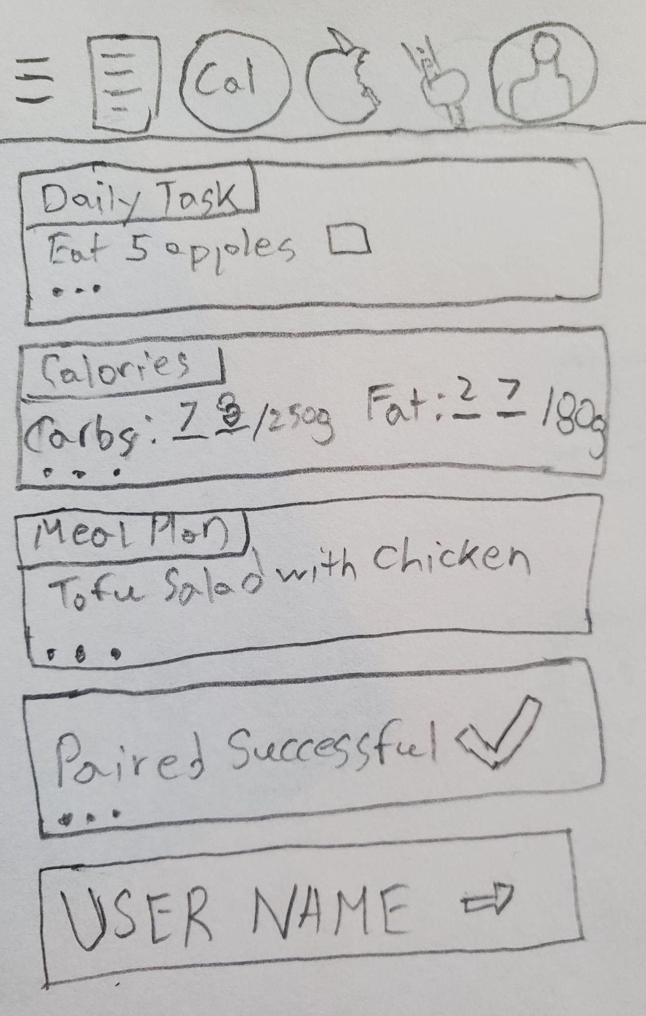

This is the homepage of my first prototype. At the top of the page, is the navigation bar. The icon with the three lines, is to toggle the navigation bar on the page. The icon with lines inside a rectangular box, is the Daily Tasks icon and will lead to the Daily Tasks page. The icon titled Cal will take the user to the Calorie Counter. The apple icon is the Meal icon, and will take the user to the foods and diet plans of the application. The watch icon is for smartwatch settings and pairing. The person icon is the Account icon, for the user profile. After logging in, the user will be led to this homepage where you get a little bit of information from each tab and links pages of the application within the rectangular boxes ranging from Daily Tasks, Calories Counter, Meal Plan, Watch Pairing, and Accounts. The Daily Task box tells the user one of their daily tasks as shown, and for more information, they would have to click on the three dots which will navigate the user to the appropriate page.

Prototype 1 Account Page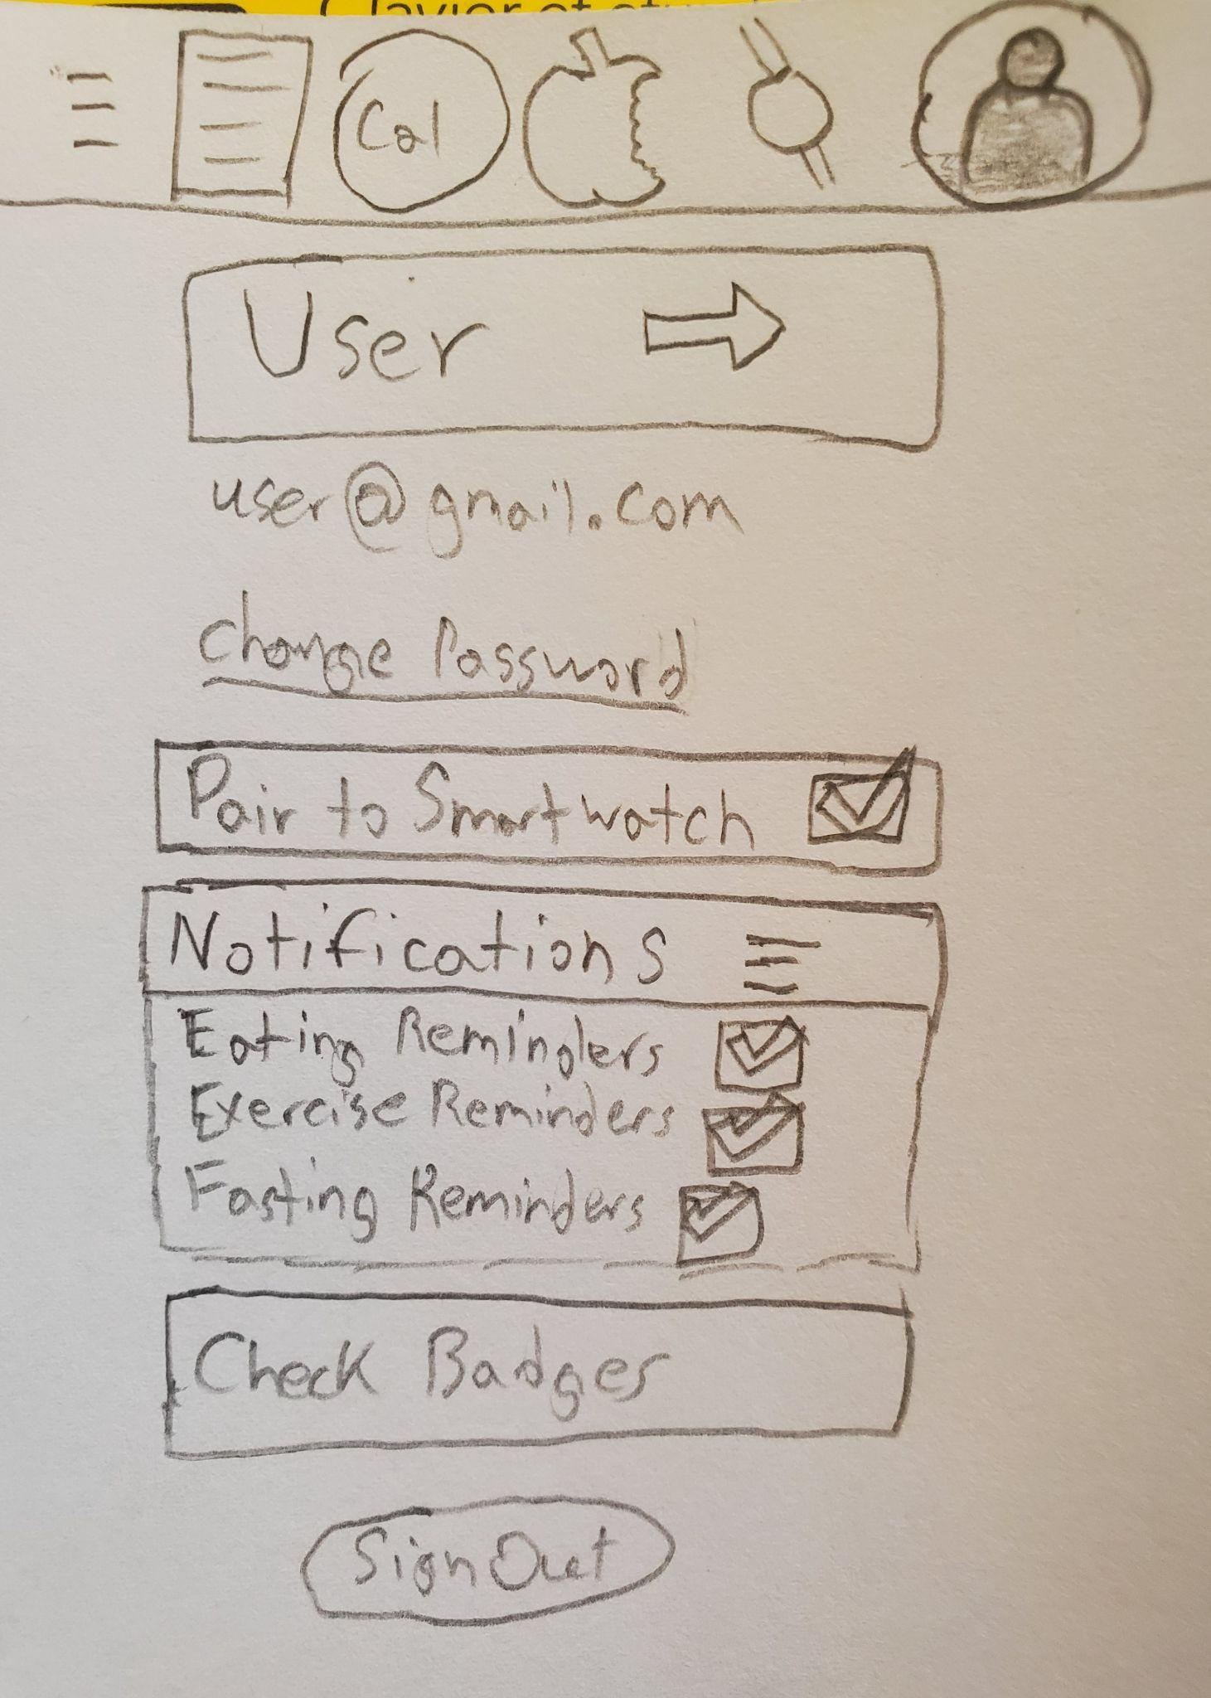

This is the account page where the user can find their personal information and application settings. The navigation bar is still displayed in the Account page, and the user can tell where they are by the darkened Account icon. The user’s name is displayed first, along with an arrow, which when clicked will take the user to their profile information such as name, birthdate, email, and more. The user’s email address is displayed and there is an option to change the password. There are checkboxes for enabling and disabling application settings. When a setting is enabled, the checkbox has a checkmark next to it as shown by the Pair to Smartwatch setting. The Notifications settings are hidden in a dropdown menu, with more checkbox settings. The Check Badges button will take the user to their achievements and badges for the completion of daily tasks and personal goals. By clicking the signout button, the user can log out of the application.

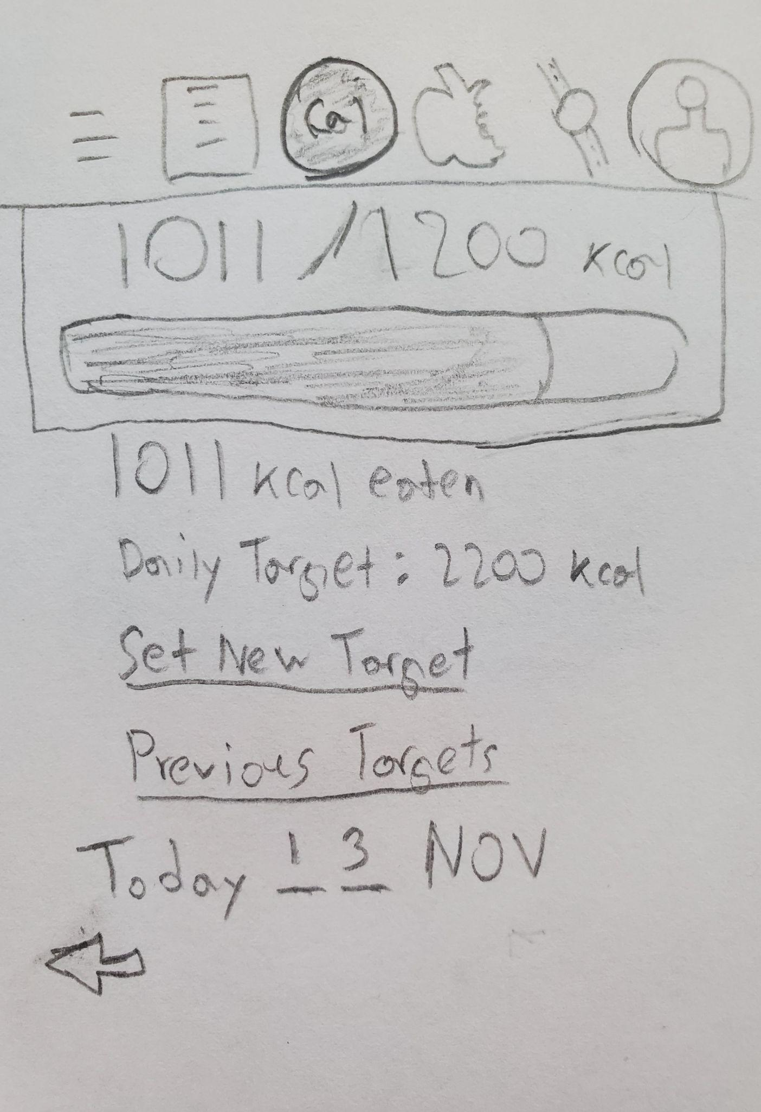

Prototype 1 Calorie Counter Page

This is the calorie counter page. The navigation bar is available on this page as well. At the top center of the page is the calorie counter tracker in the form of a bar, where the colored section indicates the calories eaten. Beneath the counter bar, is the display of calories eaten in a text format, followed by the daily target, to reinforce and motivate the user. Beneath that is the option to set a new daily target, and to check previous targets. The page also displays the current date, and the arrow icon that points left underneath the date, allows the user to look at previous calorie counter pages, and navigate between them through the arrows.

Prototype 1 Daily Task Page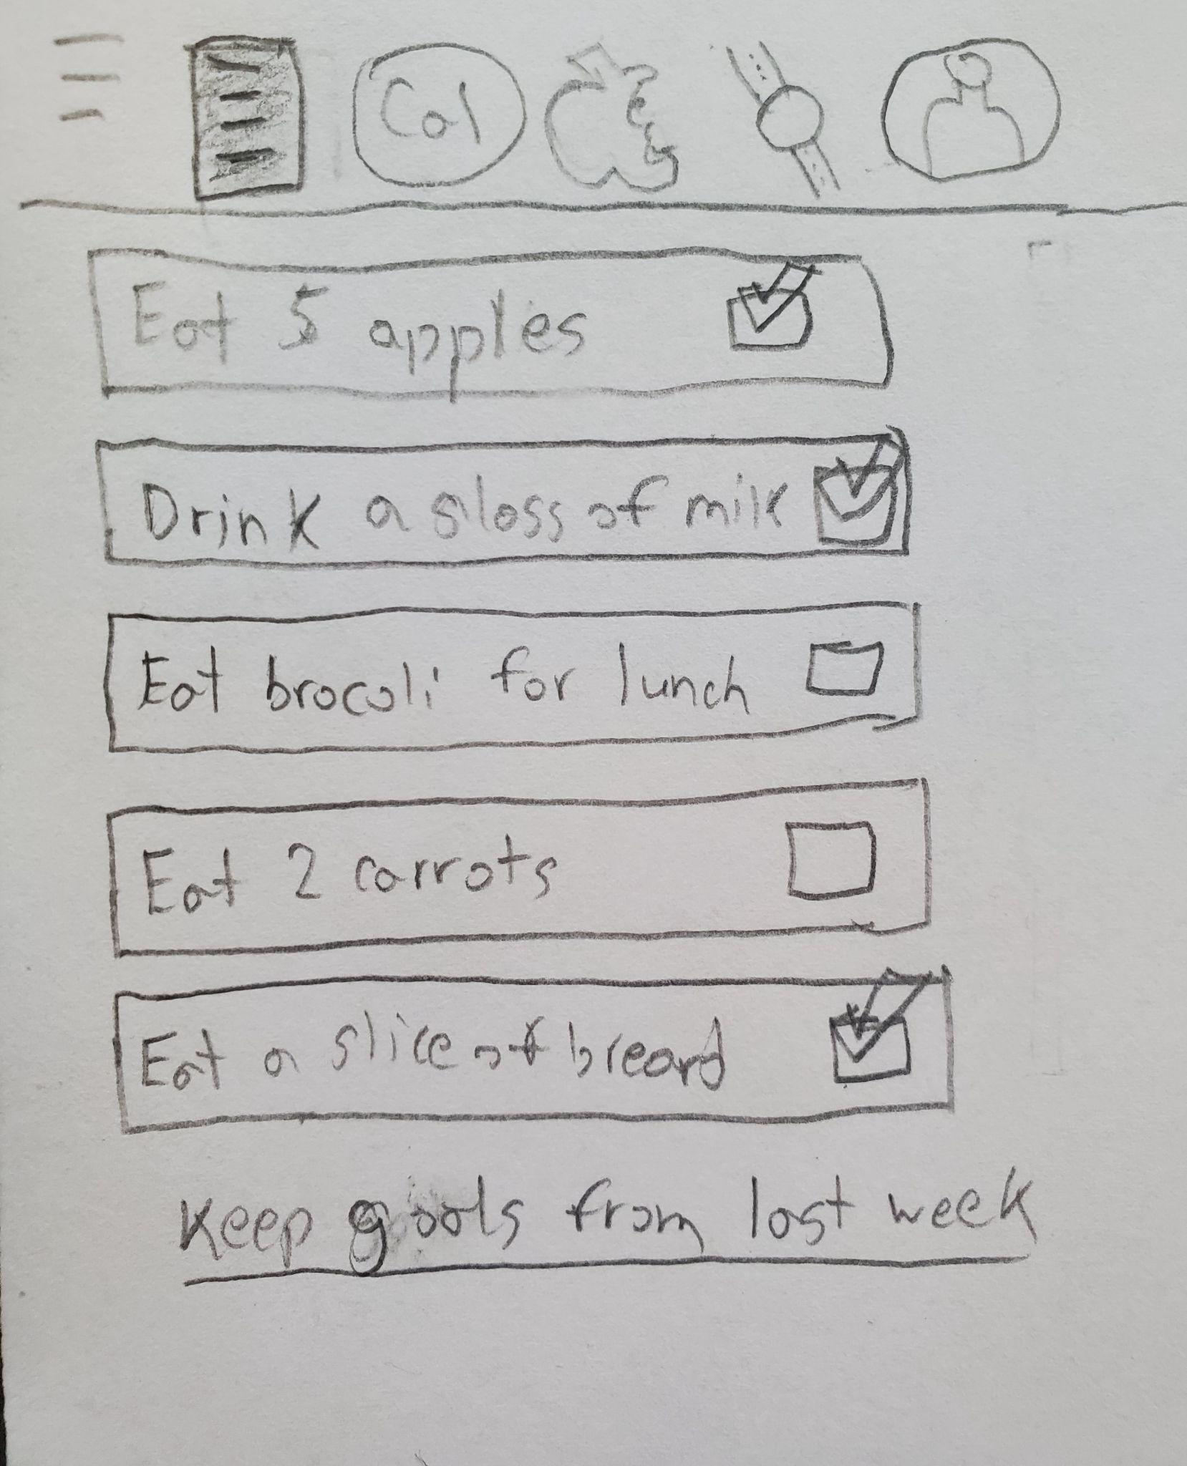

This is the daily task page. The navigation bar is available on this page, the Daily Task icon shaded in, indicating where the user is in the app. This page has various tasks in an unordered format, where recently completed tasks show up at the top with a checkbox for each task. Checking the item, indicates that the user has completed the task. The user can find various tasks by scrolling through the tasks. Beneath the tasks section, is a link that allows the user to recycle their tasks from the previous week without having to find more of them, and puts those tasks at the top of the task list.

### Prototype 2

Prototype 2 Login Page

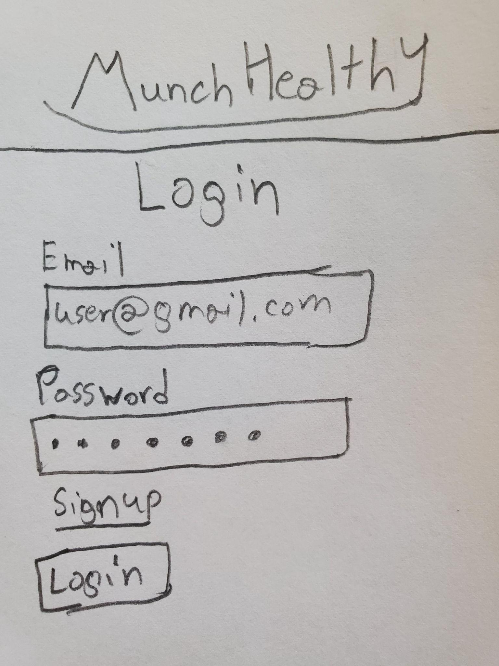

This is the login page of my second prototype. At the top, there is the application logo and name, Munch Healthy, in a simple format. It is required for the user to log in to an account to access the app's features. This allows for a more personalized catered experience for the user. For the login page, if the user has an registered account with the database, the user can login by entering their email and password in the indicated fields, and clicking the login button at the bottom will lead them to the homepage. If the user does not have an account, they can sign up for an account by clicking on the underlined sign up text.

Prototype 2 Homepage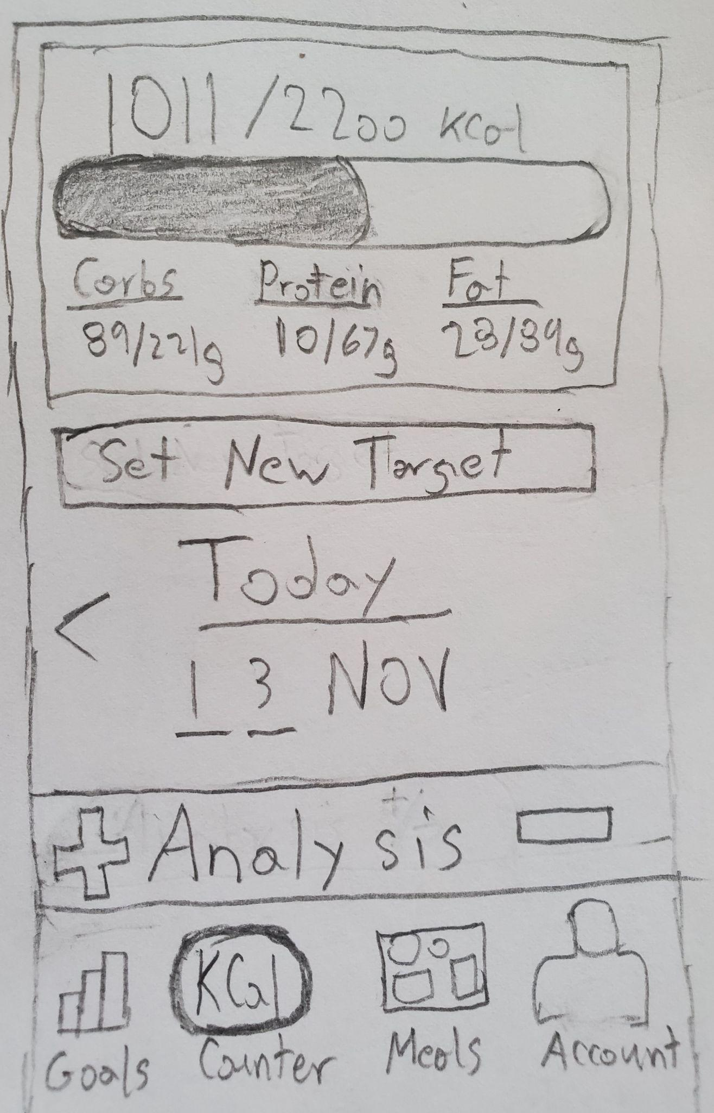

This is the homepage of my second prototype. When the user logins in, the user will be led to this page. The homepage and the calorie counter pages have been combined. At the top center of the page is the calorie counter tracker in the form of a bar, where the colored section indicates the calories eaten. Underneath it are carbs, protein, and fat sections indicating how much of each category the user has eaten. Below the counter bar, is the set new target button which allows the user to change their daily calorie target, and update the counter appropriately afterwards. Below that, the page displays the current date, and a left pointing arrow head. This allows the user to check previous calorie counter pages. The analysis button before the navigation bar allows the user to check their overall calorie statistics and fitness. The navigation bar is at the bottom of the page with four icons and a title for each icon, and a shaded icon indicates where the user is on the app. Currently on the calorie counter page, indicated by the shaded circle border with the text KCal. The bar graph icon is for the goals and daily tasks page, the food track icon is for the meal plans page, and the person icon is for the account page.

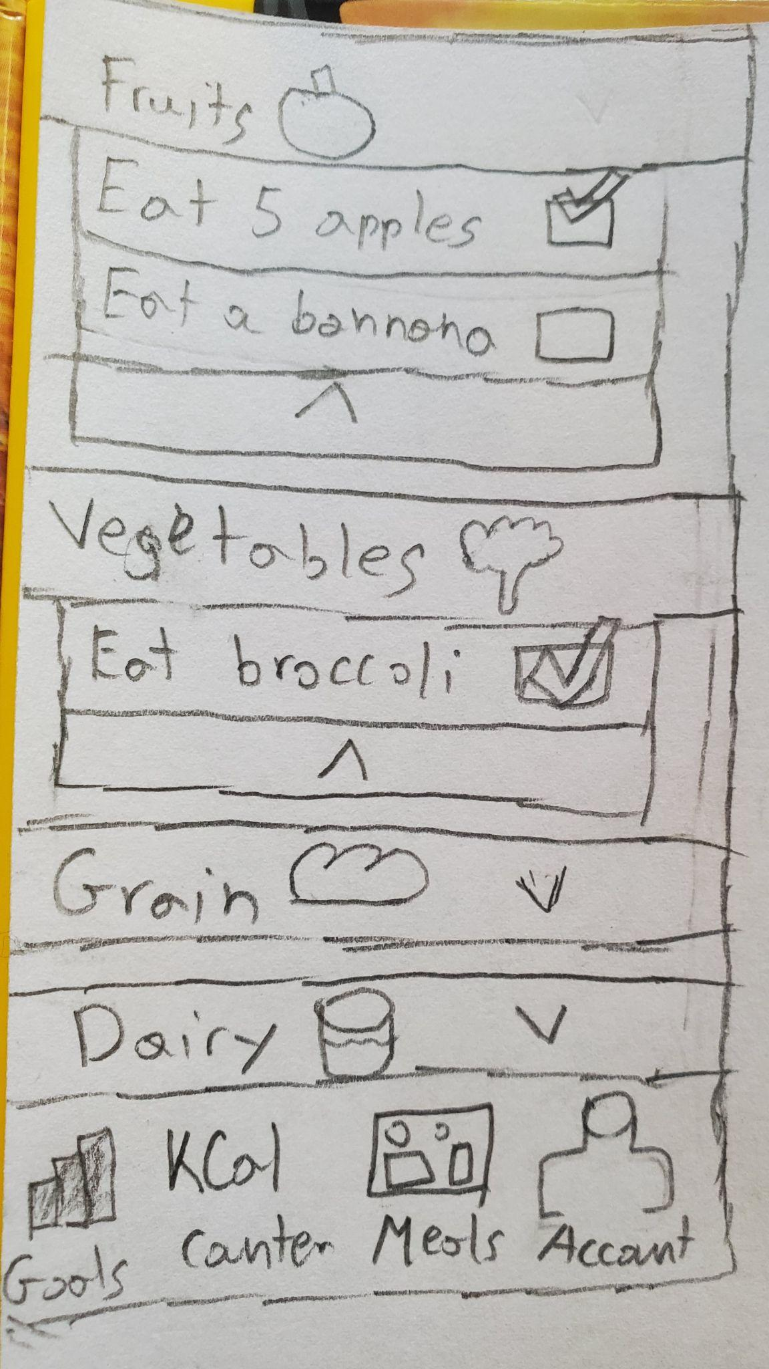

Prototype 2 Goals page

This is the goals page for the second prototype. The daily goals or tasks are sorted by food categories like fruits, vegetables, grain, and dairy. Each category is a drop down, with a title and an icon image that matches the category. By clicking the drop down, the user is introduced to checkbox items that allow the user to select goals and tasks they wish to complete. Selected and completed items are indicated by a checkmark next to the checkbox. The navigation bar is at the bottom of the page with four icons and a title for each icon.

Prototype 2 Meal Plan page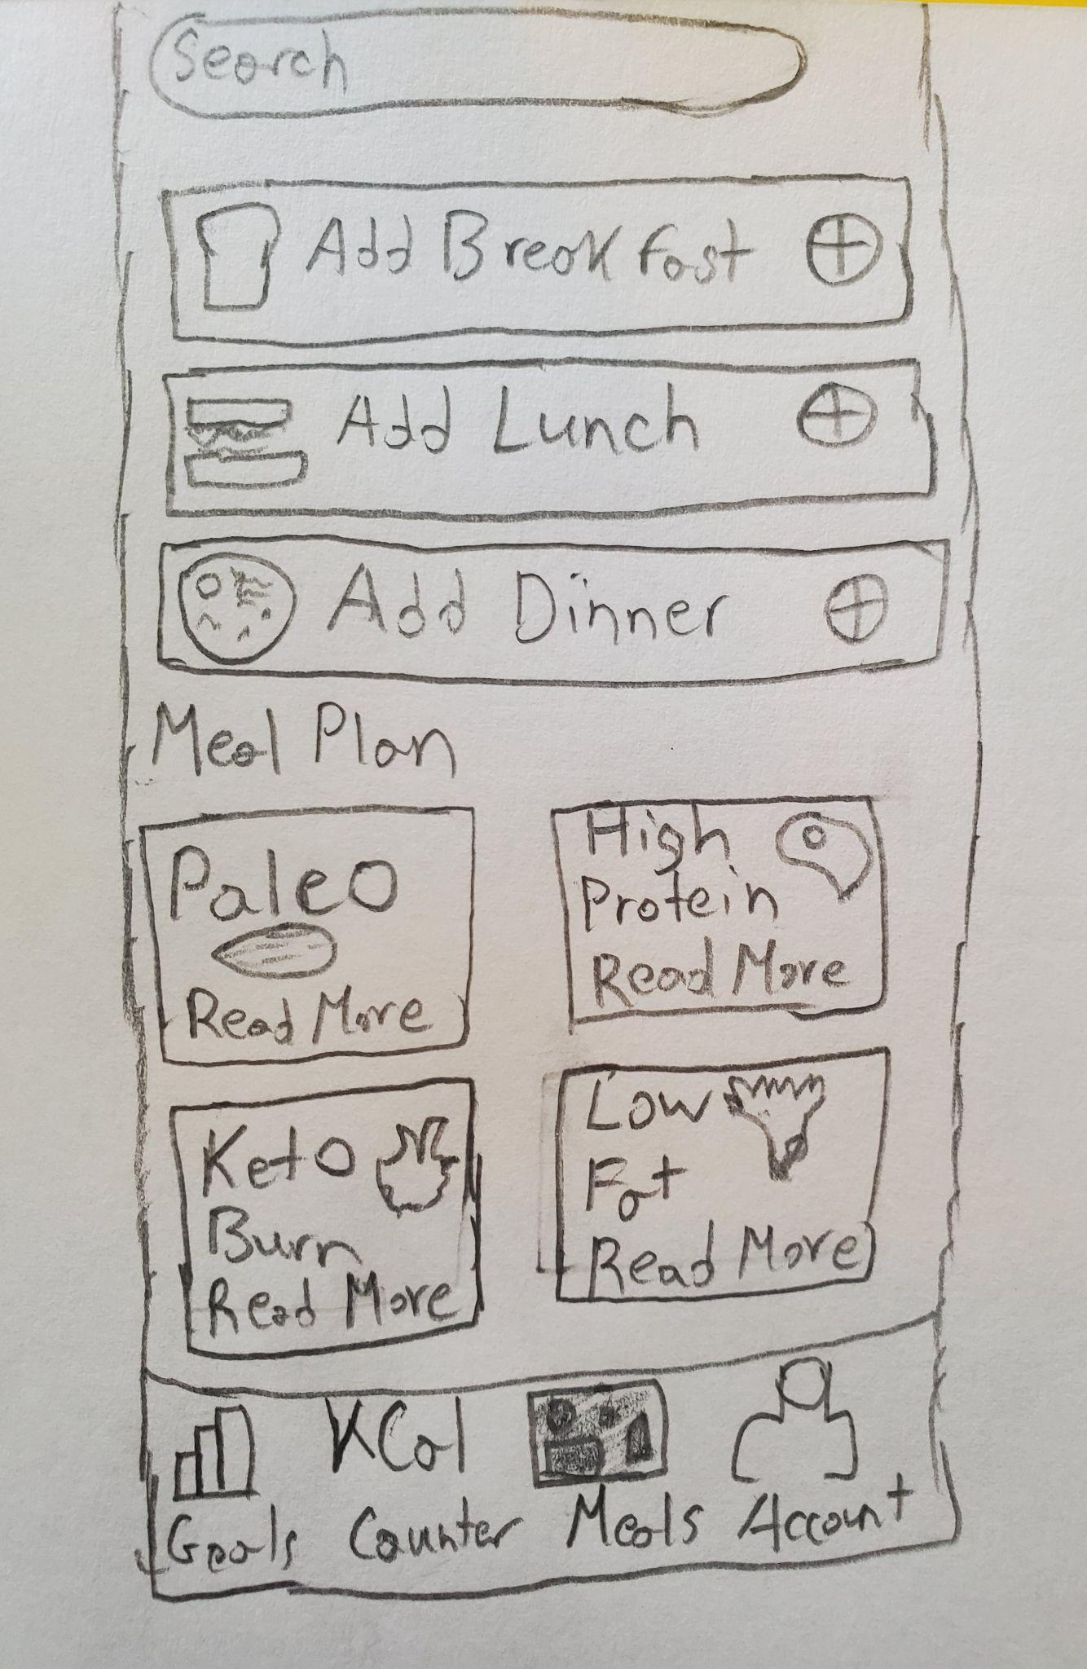

This is the meal plan page. This is where the user can find diet plans and foods in the application database. At the top of the Meal plan is a search bar, which allows the user to search for various foods within the application database to add to the daily menu, which corresponds to the foods the user has eaten throughout the day and helps to calculate and display the calorie intake with the calorie counter. Below the search bar are three buttons which allows the user to add a food item corresponding to the type of meal, breakfast, lunch and dinner by clicking on the plus icon. Afterwards, the user can find meal plans, in a table format, with the meal plans title, a matching image, and a read more text. By clicking a meal plan icon, the user can see various information about the meal plan, types of foods to eat, benefits, and more. The navigation bar is at the bottom of the page with four icons and a title for each icon.

Prototype 2 Adding Breakfast Item page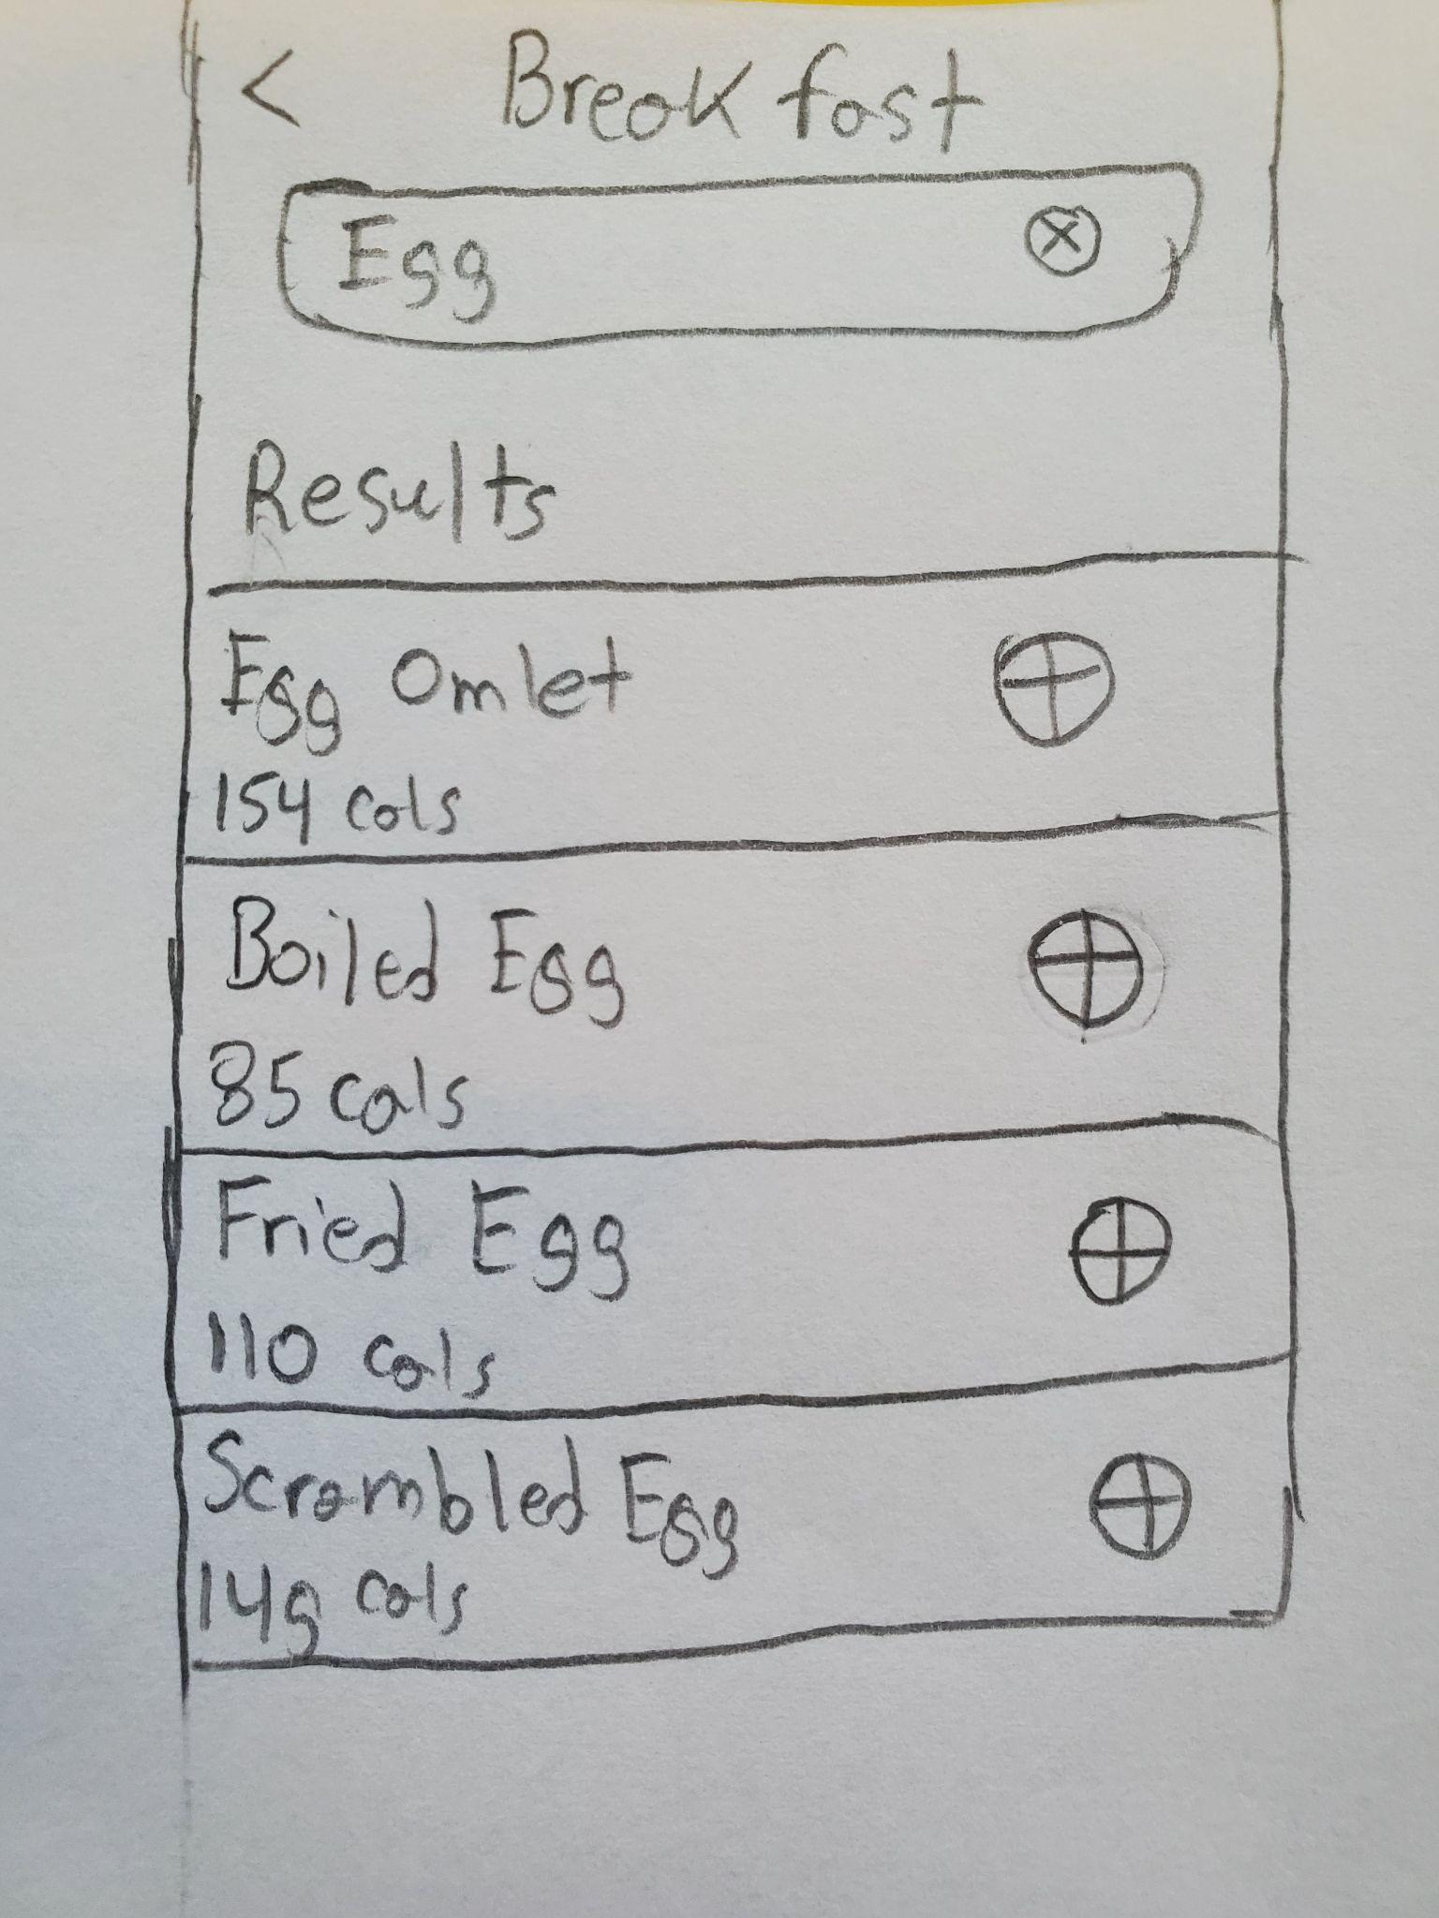

This is the adding breakfast item page. When the user clicks on the plus icon next to Add Breakfast in the meals plan page, the user must search for breakfast items using the search bar. By entering the item name, various foods with the searched name will be displayed. As shown in the prototype, searching ‘Egg’ will lead to a search result of items with the word ‘Egg’ in its name. The quired items display their calories and have an plus icon next to them, indicating that by clicking the plus icon, the user can add the food item to the breakfast category.

## Step 2 Evaluation

After evaluating the prototypes, I have decided to merge first and second prototypes, though mainly sticking with the second prototype for many features and layout. For the login page, I will be using the second prototype as it meets the requirements for a simple and clean page without cluttering the page with both login and signup features. For the homepage, I will be using the idea of the second prototype, having the homepage be the calorie counter page, reducing the number of pages needed, and making the navigation bar more simple and less cluttered with icons. Since the main idea of the application is to track the user’s diet, having the calorie counter as the homepage makes more sense and benefits the user as they always know their progress by simply opening the app. Having a homepage with information from all over the place will make my user group confused and turn down the app as being too unorganized. For the calorie counter page, instead of just showing the calories eaten, we can give the user more information about carbohydrates, fat, and protein. My user group is more keen on getting the facts and details, that they usually pay more attention to key health elements. This is why using the second prototype's information display is a good idea. However, the date feature serves no purpose for the user and for the application, it will just take up needed space that can be used for something else. The set new target and analysis features in the first and second prototypes are nice to have, but they can be more compact and hidden with an arrow drop down or something similar.

For the daily task page, a mixture of both the first and second prototype can be used, where the tasks are a bit more ordered and categorized as in the second prototype, giving the application more order and making it easier for the user to find the task and goals they wish the challenge and complete. But also using the feature of selecting previously completed tasks, with a button that reselects and displays those tasks for users who want a routine. This is beneficial for the user, since a routine means that the user is more motivated with their health goals. For the accounts page, I will be using the idea of the first prototype, since the account page gives the user their own information, and application settings. This aligns with the feature goals of having eating and fasting notifications, along with enabling smartwatch pairing, which can be done through the account page. Additionally, based on interview feedback, the awards and achievements should be personal and as such should be in the profile of the user.

For the meals page, I will be using the idea of the second prototype. This allows the user to find diet plans for their personal health and diet goals. It also allows users to input their daily diet and allows the app's calorie counter to calculate the total calories they have eaten, and various other dietary and nutritional information about the user. Additionally, I will keep the idea of the adding breakfast item page, since it allows the user to search for various foods they may wish to eat from the database as well as informs the user about the food's caloric and nutritional information. This allows the user to make their own dietary decisions based on the given information. This makes the user more likely to try various foods, and find the right taste and health benefits they desire along with making them more independent and health conscious about their eating.

## Step 3 Choice and Refinement

For my final prototype I will be using a mixture of the first and second prototype, and with additional changes on top. My decisions on which features to keep or replace were based on maintaining consistency with the page interfaces and conforming certain features, since keeping interfaces familiar and simple is important for my user group. After going through the designing process, I realized some inconsistencies in my prototypes. For the second prototype design, I realized that it did not make much sense to have the food intake within the meal plans page, as it will be more hidden from the user, and will take more effort from the user to find and add the foods they have eaten. As such, in replacement of the date feature on the calorie counter page, I will add the food intake feature here, so that after opening the app, the user can immediately input their food intake, since my user group likes things to be fast and efficient. In addition, adding a feature to favorite food items helps the user to keep track of their regularly consumed foods and makes the food adding much easier.

An important change made to the final prototype is the navigation bar. I will remove the feature to toggle the navigation bar since the navigation bar is an important feature of the application. It is the only way for the user to travel between pages, and as such it should always be available to them. I also changed the icons for the pages on the navigation bar so that they fit more with the purpose of each page and the app as a whole. The calorie counter is the first item on the navigation bar, with a book icon since it acts as a bookmark and records the user’s diet journey. The goals icon is the second icon in the navigation bar, and will be a checklist icon, as the user will pick what tasks they want to complete, and check them off, both in person and in the app. The meals page icon is the apple icon with a bit taken out, since it fits the theme of the page. The account page icon is the same but the page will be titled profile instead to make it more personal to the user.

After refining my prototype, my user base did not change. However, most of the little features are compacted and hidden. The user analysis and reports feature is hidden in the calorie counter feature within an arrow drop down, and similarly the user badges and achievements are within the user profile. They can be accessed quite easily, but they do not interfere with the normal operation of the user. In addition, when a user makes a new account, they will have to make their user profile and take a health small survey to better cater the user’s needs asking for information such as their health goal, current health status, and target goal.

## Step 4 Finalized Design

### Storyboard

| 1) The user wants to add what he has eaten for breakfast into the application, to better help track his calorie intake, and to reach his calorie intake goal for the day. The user opens the application and is greeted by the login page. The user enters his email and password on the login page and clicks the Login button. | 2) The user is taken to the homepage, the calorie counter page, titled log. The calorie values for the day are empty. The user sees the ‘Add Breakfast’ tag and the plus icon next to it, which means to add. The user clicks the plus icon for the ‘Add Breakfast’ tag. | 3) The user is taken to the add breakfast item page. The user can see a search bar and the recent breakfast items he has had with their caloric value, along with a checkmark next to some of them, indicating ‘Favorites’. The user clicks on the Favorites slider. |
| --- | --- | --- |
|  |  |  |

| 4) The user now sees only the breakfast items he has marked as favorites. The user finds the food item, ‘Keto Hashbrown Egg Cups’, that he has eaten for breakfast today, and clicks the plus icon next to it. | 5) The user is taken to the nutrition page for the ‘Keto Hashbrown Egg Cups’. The page lists various nutritional information about the food. The user clicks the ‘Track’ button, to add the item to the calorie counter. | 6) The user is taken to the calorie counter page. The user now sees an updated page with the caloric and nutritional information. The user wants to select a daily goal so he clicks on the Goals icon from the navigation bar. |
| --- | --- | --- |
|  |  |  |
| 7) The user is taken to the daily goals page to select a goal. The user clicks the drop down of the food category Fruits. | 8) The drop down expands and the user is given various goals to complete. The user selects and clicks on the goal ‘Eat 5 apples’ to complete, indicated by the darkened border of the checkbox option. | 9) The user also wants to check for any new meal plans, so he selects the Meals icon from the navigation bar, and is taken to the meals page. |
|  |  |  |

### User Experience Map

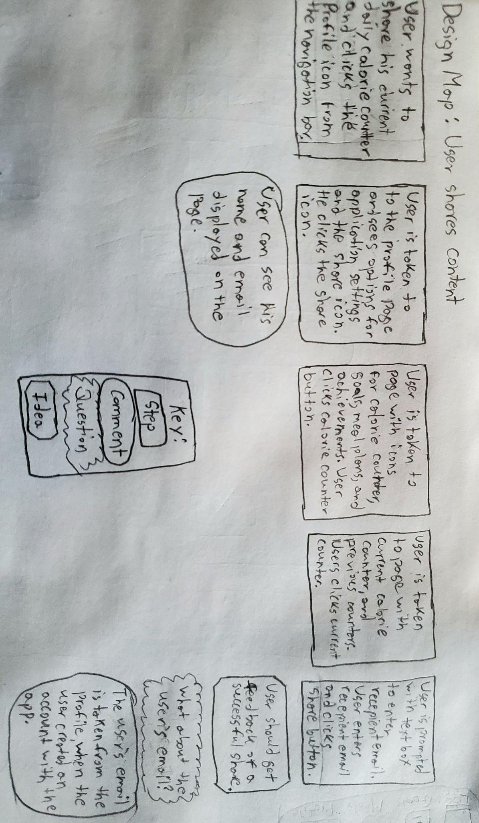

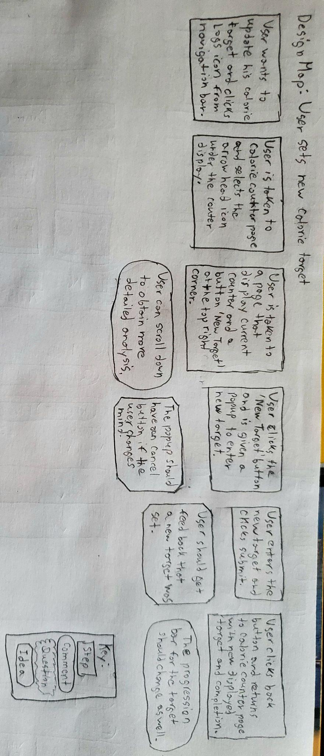

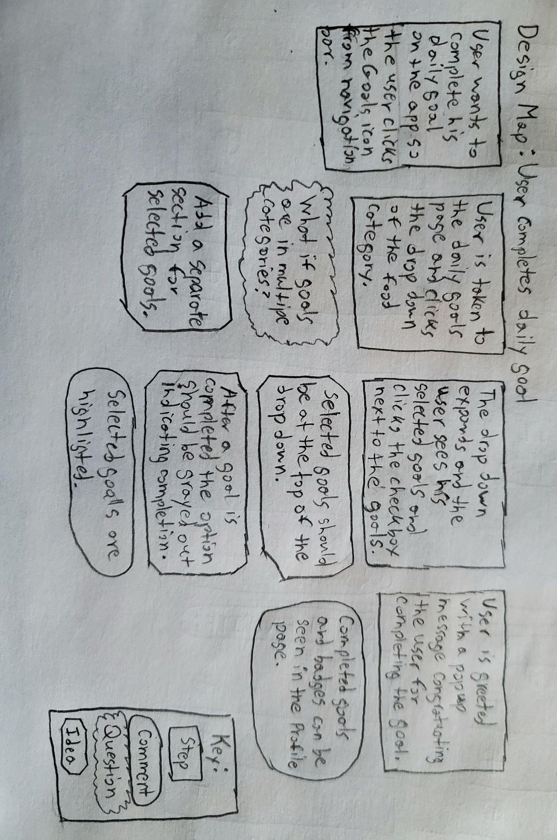

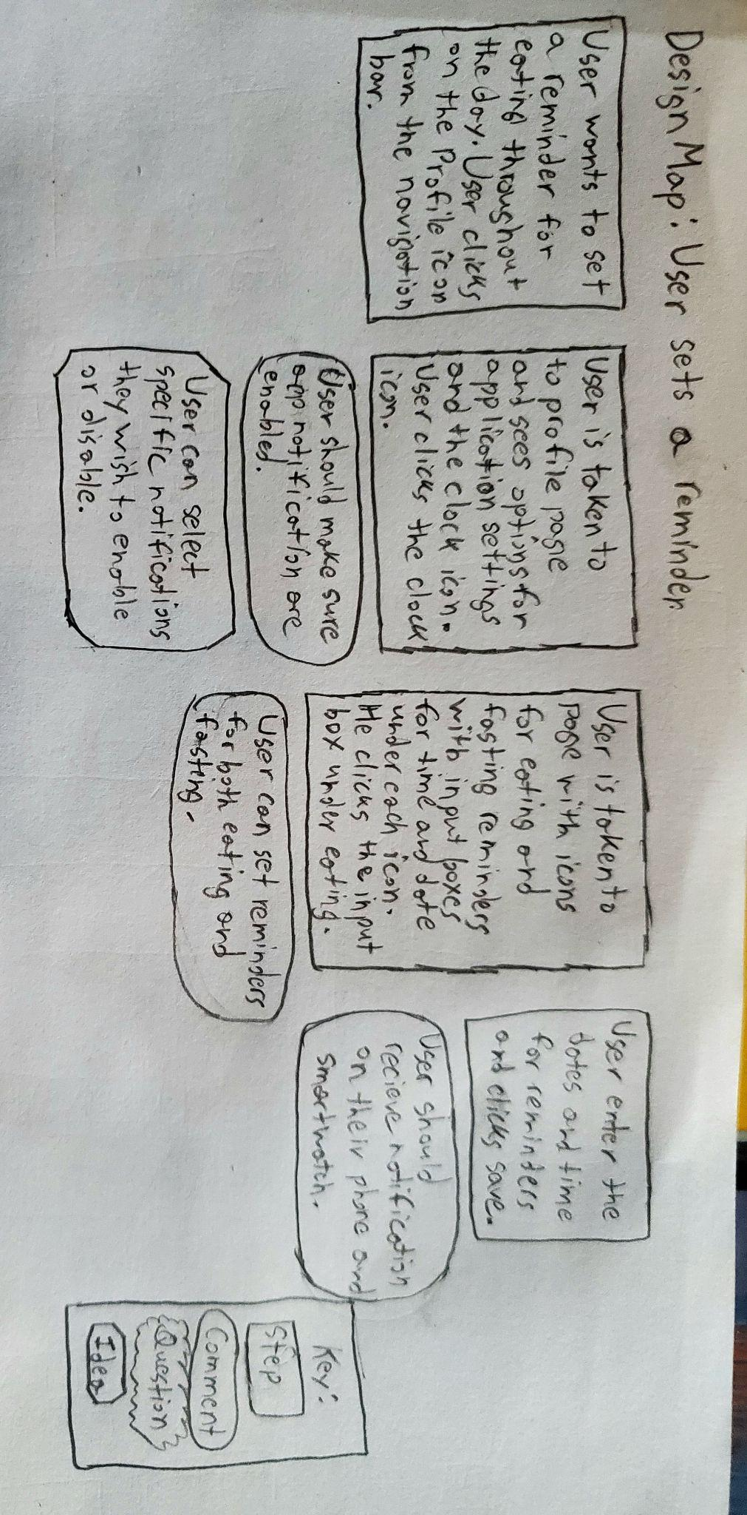

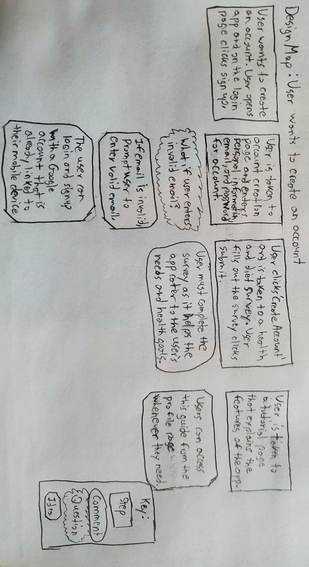

## Step 5 Lesson Learned

During the low-fidelity prototyping process, I made prototypes of my mobile app based on my app’s users, tasks, and system requirements. When making both of my prototypes, the idea behind my designs was to make them simple but to the point. After evaluating the prototypes, I decided to merge my first and second prototypes but decided to keep and focus more on the features based on the second prototype. Then, I created a storyboard of my final merged prototype and a user experience map for a set of user tasks. While I was making the storyboard and the user experience map, I began to refine more of my ideas. But more importantly, I realized the flaws and weaknesses of my first and second prototypes and began to fix and implement new ideas that came to mind. After going through these steps, I learned just how important prototyping is to the development of a product, and how each step is just as important as the next. The flow in progress helps to keep you on track while refining ideas and improving at each step. As I went through the process, I learned something new about my app and improved my app. Without being able to simulate user experience and act out their actions and thought processes when interacting with the app, I would never have been able to improve my app past the prototype and discover the various defects that my interface holds. I can say with confidence that after going through this, my perception of computer interfaces has changed drastically and has had a profound impact on me in a good way moving forward.

# **4. Digital Prototype**

The digital prototype was made using an online prototyping software Proto.io (Proto.io, 2019).

## Sign In Page

The Sign In page is the first screen a user will see when they open the Hunch Healthy app. It will display the Munch Healthy logo, provide fields for the user to enter their Email and Password to sign in. If the user already has an account with the app, they can enter their user credentials and sign in by tapping the Sign In button. If the user does not have an account they must create one by tapping on the Create Account button.

## Sign Up Page

After the user taps the Create Account button, they will be directed to the Sign Up page where they can create their account. If the user already has an account or changes their mind, they can go back to the Sign In page, by tapping the back arrow button on the top left corner or the highlighted sign in text. The page provides the user with input fields which must be filled to create an account. The fields include basic information like name, email, password, date of birth, gender, and phone number. When the user is done, tapping the Done button on the top right corner will create the account and direct the user to a survey.

## Survey Page 1

The Survey page asks the user their purpose for coming to the app. This helps to better understand the apps users and can better cater to their needs. It also allows for better marketing to the right users. Tapping on the back arrow will lead the user back to the Sign Up page, if they need to change certain details. Tapping on any of the goal buttons will direct the user to the second Survey page.

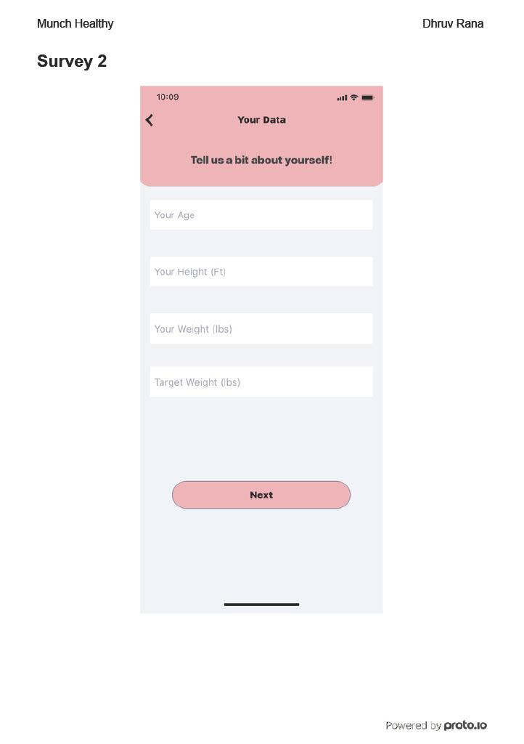

## Survey Page 2

The second survey page collects user data such as age, height, weight, and target weight. This data helps to better cater service to the user. The user will input their data into the given input fields, and when finished, tap on the Next button. If the user wishes to go back to the previous page, they can go back by tapping the back arrow.

## Calorie Counter Page 1

When the user signs in or creates an account, the user will be led to the calorie counter page. This page acts as a homepage for the app. The user will see their net calories as a circular counter, as well a counter for carbs, protein, and fat. To track a food item, the user must select the plus icon next to the food categories of breakfast, lunch, and dinner. The user can also navigate to other pages on the app through the navigation bar at the bottom of the screen.

## Breakfast Recent Food Items Page

After the user selects the plus icon button for Add Breakfast in the Calorie Counter page, the user will be directed to the breakfast food items page. If the user wishes to go back to the Calories Counter page, they can tap the back arrow button. This page contains a search bar, which the user can use to search for breakfast items. This page contains a slider, which will switch the screen from Recent food items to Favorite food items. Each food item in the Recent tab consists of a name, calories, and a plus icon button. Tapping the plus icon next to an item will lead to the food items details page. The checked marked items are items that are favorited items. To view more food items, the user can scroll through the page.

## Breakfast Favorite Food Items Page

By tapping the Favorites slider, the user will be redirected to the favorites page for breakfast items. If the user wishes to go back to the Calories Counter page, they can tap the back arrow button. This page contains a search bar, which the user can use to search for breakfast items. This page also contains a slider, which will switch the screen from Favorites food items to Recent food items. Each food item in the Favorites tab consists of a name, calories, and a plus icon button. Tapping the plus icon next to an item will lead to the food items details page.

## Keto Hashbrown Egg Cups Details Page

When the user selects the Keto Hashbrown Egg Cups from the Favorites tab, the user will be directed to the food details page. This page gives the user nutritional information about the food item such as total calories, carbs, protein, and fat. It also showcases other benefits or disadvantages the food item possesses. There is a drop-down from which the user can select a quantity for the food item. By tapping the Track button, the user will track the food item and be redirected to the Calorie Counter page. The user can tap the back arrow button to navigate back to the Favorites page.

## Calorie Counter Page 2

When the user tracks the keto hashbrown egg cups food item, the user will be led to the Calorie Counter page. This time, the page will display the consumed net calories, carbs, protein, and fat after tracking the food item. The progress bar for each will be filled in for each category. If the user chooses to track more than one hashbrown egg cup, different calorie counter information will be displayed to the user. Additionally, the tracked food item will be displayed under the respective food category, in this case, it is breakfast, enabling page scrolling. If the user wishes to track a breakfast item again they can tap the plus icon button next to Add Breakfast again. The user can also navigate to other pages on the app through the navigation bar at the bottom of the screen.

## Daily Task Page

If the user wishes to complete daily tasks, the user can select Daily Task from the navigation bar to travel to the Daily Task page. This page displays daily tasks grouped within drop-down menus of food type categories such as fruits, vegetables, grain, dairy, and meat. By selecting the Fruit category, a drop-down will appear with the daily tasks as checkbox selection items. When the user selects a task, a checkmark will appear next to the task, indicating the selected task. When the user has completed the task in reality, the user can tap the Complete Task button, which will trigger a pop congratulations message motivating the user. In addition, an achievement will pop up for the user for a brief moment. Tapping the Close button on the message will close the message. If the user wishes to select previous tasks to complete, the user can tap the underlined set previous goals text. The user can also navigate to other pages on the app through the navigation bar at the bottom of the screen.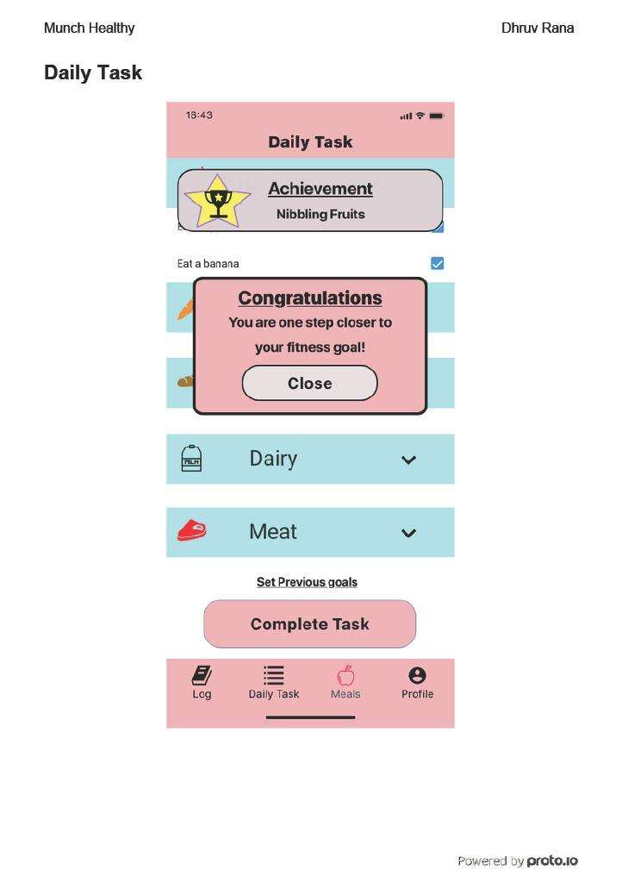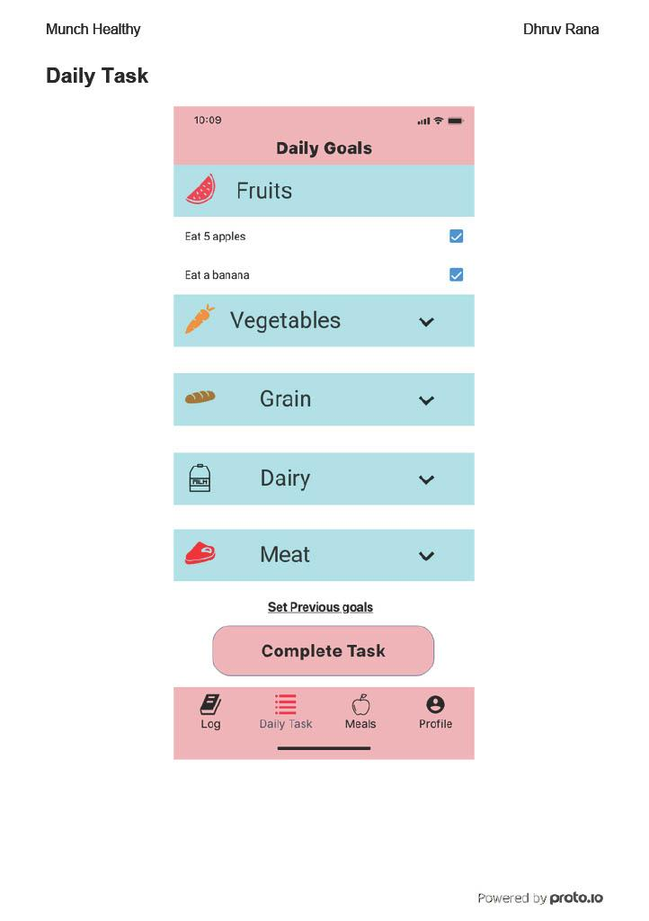

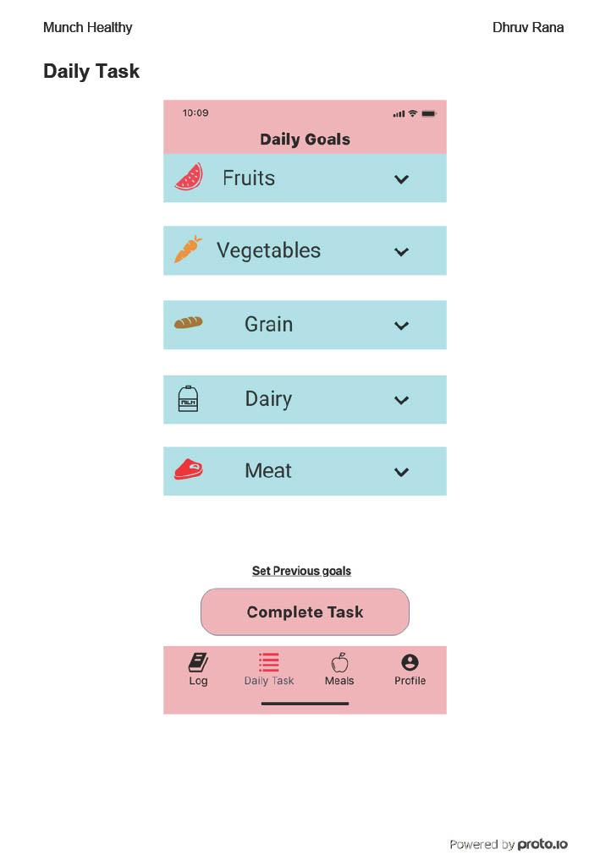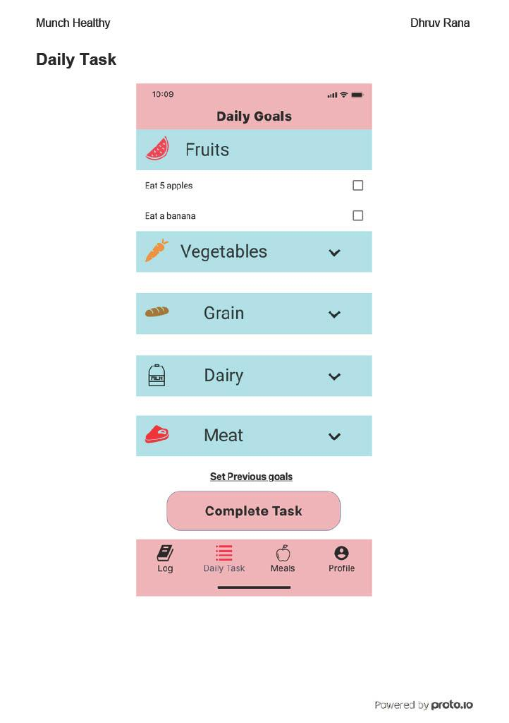



## Meals Page

If the user wishes to view various meal plans or diet plans, they can visit the Meals page through the navigation bar. On the Meals page, the user can find various diets that they can follow for their dietary and health goals. The Meals available include keto burn, paleo, high protein, sugar detox, Mediterranean, low cholesterol, and vegan. For a better view of the available diet plans, the user can scroll up on the page.

## Diet Plan Page

By tapping on the Paleo box on the Meals page, the user will be directed to the Diet Plan page. This page displays a paleo keto burn 7-day plan for beginners, suggesting various foods to eat throughout the day for 7 days, as well as the recommended calories consumed for that day. Additionally, the user can heart or favorite the meal plan for later use. The user can travel back to the Meals page by tapping the back arrow button.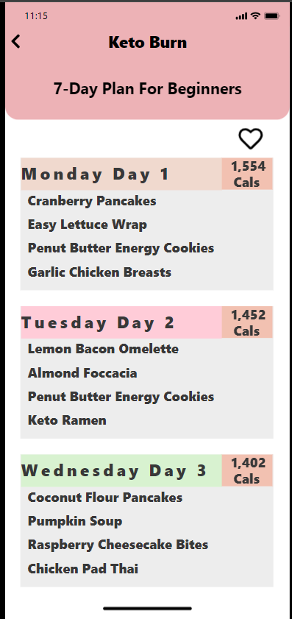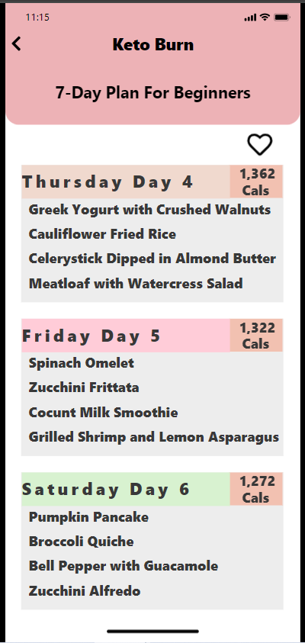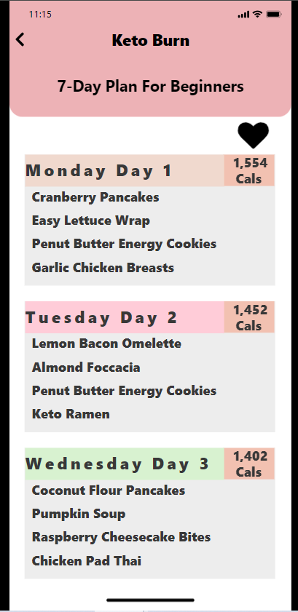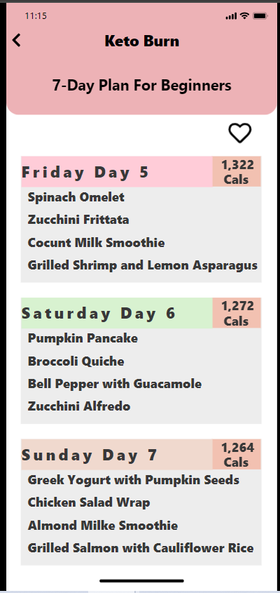

## Profile Page

The user can travel to the Profile page using the navigation bar. On the Profile page, the user can find a profile avatar image, and their profile information such as name, and email address. The user can also find the option to change their profile picture through the camera icon, set an eating and fasting timer through the clock icon, and change their account password in the Account section. The user can scroll through the Profile page to find the Settings section which enables the user to turn on and off app settings such as permissions, ads, notifications, and smartwatch pairing. The user will also find the Achievements section, which shows all the achievements. The colored achievements are the complete ones and the darker uncolored ones are the incomplete ones. The user can also find options for app Help, About Application, Send Feedback, and Support. At the bottom of the page, is the Sign Out button, which when tapped will sign out the user and redirect them to the Sign In page. The user can quickly travel to the Sign Out button by tapping the down arrows on the top left corner.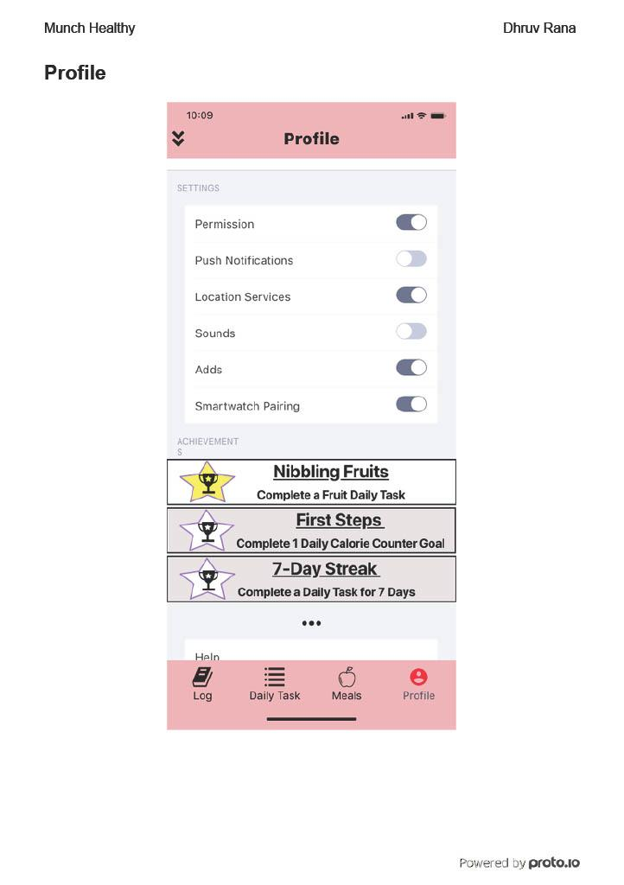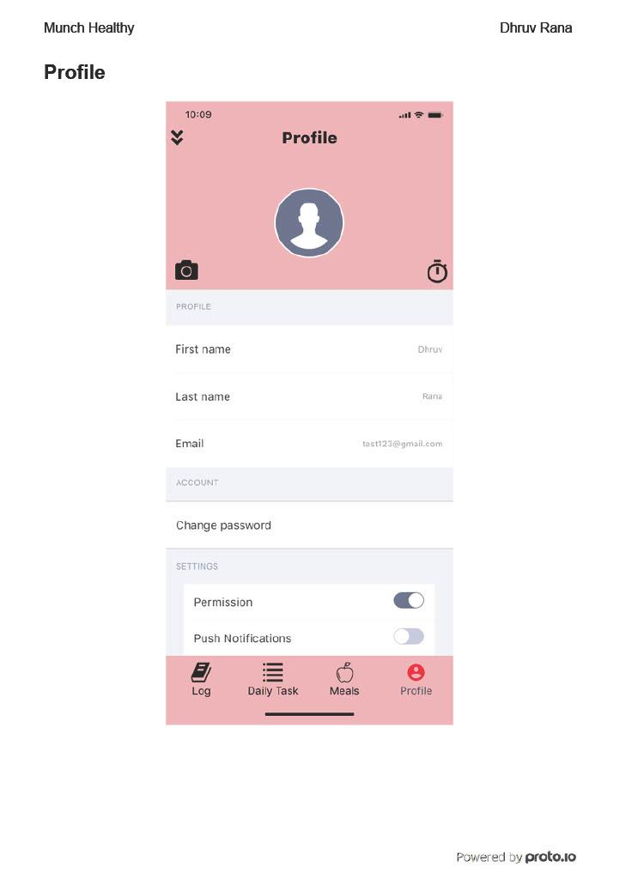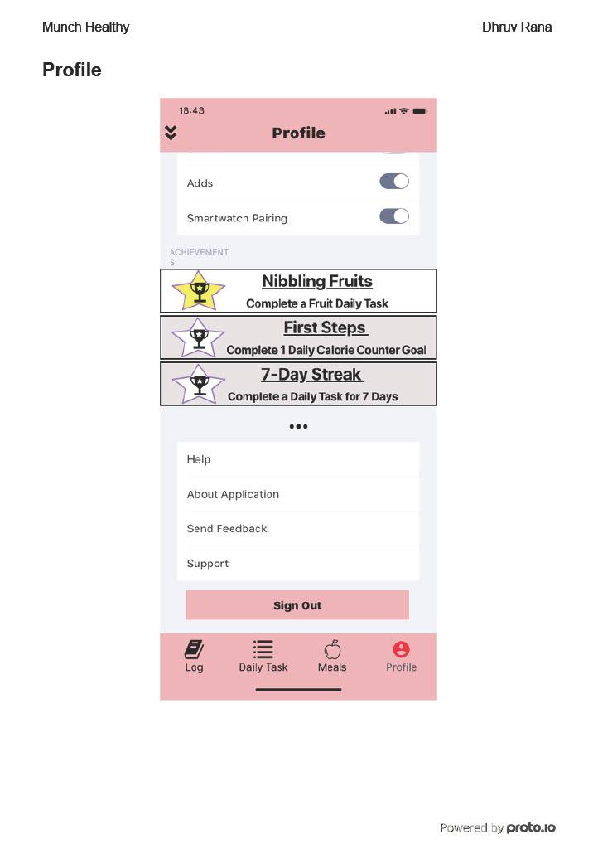

# 5. Implementation and Future Plans

The digital prototype successfully demonstrates the features for Sign In, Create Account, tracking food Items, Calorie Counter, viewing meal Plans, and Profile Page. From the current observation of the digital prototype, a few issues need to be addressed, and details that need to be improved upon. One such improvement is the addition of background images, as the background color for all the pages of the app was white. Another visual improvement would be the use of icons for food items, to better help categorize them for the user and be more appealing to the eye. A major future implementation for the application would be the use of voice commands for navigating the app and the search for food items. The majority of the app is about tapping through the pages, which can be tiring so having a voice-command feature will better help the user navigate the app functionally, and accommodate users with accessibility issues.

There are still some features that were not implemented due to time constraints, which would make Munch Healthy even better. One highly requested feature from the interviewers was smartwatch pairing. Users today have their smartwatches on themselves all the time, and can be an easier and convenient way to interact with the app and view the calorie counter, while also collecting user health data. In terms of data, another requested feature was the ability to view user diet and health data, which in the future, will give users the ability to better track and understand their health. The other highly requested feature that will be implemented in the future is social media sharing. Allowing users to share their diet goals, health data, achievements, food items, and meal plans with others on social media through the use of a share button next to the calorie counter, health report on the profile page, and meal plans. The share button would allow the user to pick which social media they wish to share with, and then after selection, it would lead the user to the social media’s login, and connect the two apps. Some smaller features that can be added in the future are the ability to add an avatar image to the profile page, as well as the ability to set fasting and eating timers and reminders.

For future implementations of the create account feature and the login feature, it is necessary to obtain user information. It will be best to create a user registration form where new users can sign up for an account using HTML, PHP, CSS, and JavaScript. The form will collect necessary information such as username, email address, password, and any other relevant details, and store it in a database like MySQL on phpMyAdmin. By implementing server-side validation to ensure that the provided information is valid and meets the strong password policy. When the user enters their password, the password will be hashed and securely stored in the database using hashing algorithms like bcrypt. During the account creation process, ask the user for personal information which can be used to make their profile later on. For the user login, create a form where the user can enter their username and password to log in using HTML, PHP, CSS, and JavaScript. When attempting to log in, the server will retrieve the user’s data from the MySQL database, check the user’s credentials and authenticate them. By implementing a token-based authentication using JSON Web Tokens with Node.js, a JWT is securely on the client side and verifies the token on the server side when logging in to ensure that it is the right user. For each login, set a token expiration time to improve security and the expiration time will be refreshed based on the user’s activity on the app, so the user does not have to log in every time they open the app.

To better improve the accuracy and efficiency of the calorie counter, I would implement a mixed approach combining database lookup for common food items and a calculation algorithm for custom or user-defined foods based on the nutrition values of the items used to make the food. Using JavaScript to implement the USDA FoodData Central API (FoodData Central, 2013), makes it easier to look up food data and implement a calorie calculation algorithm based on already provided nutritional data. An API related to the USDA also provides accurate and trustworthy information. In addition to the use of an API for the calorie counter, for efficient and accurate food tracking, the same API will be used, in addition to a barcode scanner feature. I would combine manual entry and barcode scanning features to allow for faster, more flexible, and more accurate results. The USDA FoodData Central API provides nutritional information for various foods so you can implement the library using JavaScript, and so when the user searches for a food item using the search bar feature, the server fetches the information from the API. For the barcode scanning, use Scandit, an SDK (Scandit, n.d.). A pre-built SDK makes it easier to turn a phone camera into a barcode scanner, so a user always has a barcode scanner on them.

For the implementation of the meals plan page, it’s much easier to use predefined meal plans as it reduces the need for additional forms and retrieval of data from the user. The predefined meal plans are stored in the MySQL database, and the front end is made using HTML, CSS, and PHP, when the user requests to view a meal plan, the data is retrieved and presented to the user in the front end view. This also means that resources are better allocated to other processes. For the profile page, the collection of user information will occur during account creation and then store the profile data in a MySQL database as it can be stored for longer periods, under admin control. Then use JavaScript and PHP for retrieving user-specific data using user JSON Web Tokens, and display the data to the user on a profile using HTML, and CSS. In case the user wants to make updates to their profile, an updates feature will be implemented, which is another form where the user can input new information. This information is then saved into the database. The profile page will also have a sign-out button, which when tapped will expire the user’s token, signing them out of the app.

These are some of the features that the app will have in the future, and how the implementation process behind the features. While there are still plenty of changes and necessary features to implement, it is undeniable that Munch Healthy will be able to cater to the user’s needs. Munch Healthy is made with the user in mind, and it will provide the user all that they need to “Munch Healthy Live Healthy.”

# 6. Citations

De Ridder, D., De Wit, J., & Adriaanse, M. A. (2009). Making plans for healthy diet: The role of motivation and action orientation. *European Journal of Social Psychology*, *39*(4), 622-630.

*FoodData Central*. (2013). Usda.gov. <https://fdc.nal.usda.gov/api-guide.html>

*Healthy Weight Loss & Eating: Lose Weight Fast with YAZIO*. (n.d.). YAZIO. <https://www.yazio.com/>

Leung, P., Wanitprapha, K., & Quinn, L. A. (1995). A recipe-based, diet-planning modelling system. *British Journal of Nutrition*, *74*(2), 151-162.

Proto.io. (2019). *Proto.io*. Proto.io. <https://proto.io/>

Räsänen, L., & Pietinen, P. (1982). A short questionnaire method for evaluation of diets. *Preventive Medicine*, *11*(6), 669-676.

*Scandit: Smart Data Capture and Barcode Scanning Software*. (n.d.). Scandit. <https://www.scandit.com/>

U.S. Department of Agriculture. (2020). *MyPlate*. MyPlate; U.S. Department of Agriculture. <https://www.myplate.gov/>